JOURNAL SECTION

Paper Title

Author(s) Name(s)
Author Affiliation(s)
E-mail

Abstract
The abstract is to be in fully-justified italicized text as it is here, below the author information. Use the word “Abstract” as the title, in 12-point Avenir Book, boldface type, centered relative to the column, initially capitalized. The abstract is to be in 11-point, single-spaced type.

Keywords: List keywords here, separated by semi-colons

Introduction
Please follow the steps outlined below when submitting your final draft to the TLA Journal. These guidelines include complete descriptions of the fonts, spacing, and related information for producing your proceedings manuscripts. Please direct any questions to Angela Jenks, Editor-in-Chief at ajenks@uci.edu.

Formatting Your Paper
All printed material, including text, illustrations, and charts, must be kept within the parameters of the 8.8-inch column length and 5.9-inch column width. Please do not write or print outside of these parameters. Margins are 1.2 inches on the left side, 1.2 inches on the right, 1.0 inch on the top, and 1.2 inches on the bottom. Paper orientation in all pages should be in portrait style.

Main Title
The main title (on the first page) should be in Avenir Book 14-point, boldface type. Capitalize the first letter of nouns, pronouns, verbs, adjectives, and adverbs; do not capitalize articles, coordinate conjunctions, or prepositions (unless the title begins with such a word) (e.g. A Comparative Study of Privacy Protection Methods for Smart Home Environments). Leave one blank line after the title.

Author Name(s) and Affiliation(s)
Author names and affiliations are to be centered beneath the title and printed in Avenir Book 12-point, non-boldface type. (See example below)

Affiliations
Affiliations are centered, italicized, not bold. Include e-mail addresses if possible.

For example:

Author¹, Author² and Author³

¹Affiliation
²Affiliation
³Affiliation
¹Email, ²Email, ³Email

Corresponding Author
Corresponding author should have an asterisk sign (*) if possible, after the corresponding author’s name. The corresponding author label (e.g., *Corresponding Author) should appear at the footnote section of the first page of the paper, Avenir Book in style and 9 in font size.

Second and Following Pages
The second and following pages should begin 1.0 inch from the top edge. On all pages, the bottom margin should be 1.2 inches from the bottom edge of the page for 8.5 x 11-inch paper.

Main Text
Type your main text in 11-point Avenir Book, single-spaced. Do not use double-spacing. All paragraphs should be indented 0.17-inch or 0.43 cm. Be sure your text is fully justified, flush left and flush right. Please do not place any additional blank lines between paragraphs.

Tables
Place tables as close as possible to the text they refer to and aligned center. A table is labeled Table and given a number (e.g., Table 1. Sample Datasheet with Attributes in Linguistic Term) it should be numbered consecutively. The table label and caption or title appears a 12-point space above the table and 6-point space after the text or paragraph, if any; it should be in Avenir Book 11-point font, capitalized similar to paper title, aligned center, and bold face. Sources and notes appear below the table, aligned left. All tables must be in portrait orientation.

For Example:
Table 1. Table Label

Figures
Place figures as close as possible to the text they refer to and aligned center. Photos, graphs, charts, or diagrams should be labeled Figure (do not abbreviate) and appear a 6-point space below the figure, 12-point space before the next text or paragraph, and assigned a number consecutively. The label and title should be in line with the figure number (e.g., Figure 1. Location Error Rate of Three Schemes), it should be in 11pt font size and Avenir Book style, capitalized similar to paper title, aligned center, and bold face. The source (if any) should appear underneath, flush left. Figures should be clearly readable.

For Example:

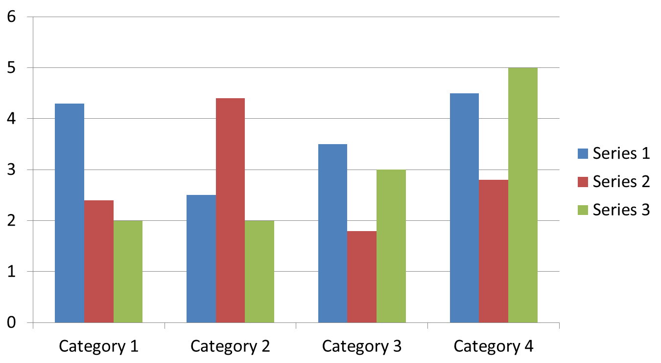

Figure 1. Figure Label
Photographs or Images
All photographs or images should be by the author, in the public domain, or licensed under an appropriate Creative Commons license to allow for republication.
First-order Headings
For example, “Introduction”, should be Avenir Book 13-point boldface, initially capitalized, flush left, with one blank line before the heading and 6-point space after.

Second-order Headings (Sub-headings)
As in this heading, they should be Avenir Book 11-point italicized, initially capitalized, flush left, with one blank line before the heading and 6-point space after.

Footnotes
Use footnotes sparingly (or not at all) and place them at the bottom of the column of the page on which they are referenced. Use Avenir Book 9-point type, single-spaced. To help your readers, avoid using footnotes altogether and include necessary peripheral observations in the text (within parentheses, if you prefer, as in this sentence).

Acknowledgments
These should be brief and placed at the end of the text before the references.

References
Teaching and Learning Anthropology Journal uses the Chicago Manual of Style Author-Date format for citations. DOIs should be included if they are available. For example:

Journal Article
Kelly, Lauren, Neha Raheel, Juliet Shen, and Arjun Shankar. 2017. “Anthropology, Film, Pedagogy, and Social Change: Reflections from an Experimental Course.” American Anthropologist 119 (1): 147-53. https://doi.org/10.1111/aman.12827

Book
Greene, Stuart and April Lidinsky. 2008. From Inquiry to Academic Writing: A Practical Guide. Boston, MA: Bedford/St. Martins.

Chapter in a Book
Morgan, Lynn. 2001. “Latin American Social Medicine and the Politics of Theory.” In Building a New Biocultural Synthesis: Political-Economic Perspectives on Human Biology, edited by Alan H. Goodman and Thomas L. Leatherman, 407-24. Ann Arbor: The University of Michigan Press.

Author Agreement
You must sign the author agreement form in eScholarship when you submit your paper. We must have this form before your paper can be published in the JOURNAL. If you have any questions, please contact Angela Jenks at ajenks@uci.edu.

